Relative Clause Attribute

✅ What is Relative Clause Attribute?
# Source: AI Source: Provided by: [Data Path: Persons Table -> ID Column: 1, Name_En Column: Motasem Essam] -> From: [Chatgpt (GPT‑5 Mini)] on [8/7/2025]
A Relative Clause Attribute is a dependent clause (also called an adjective clause) that modifies a noun or pronoun in a sentence.
It gives additional information about the noun, functioning as an attribute by acting like an adjective.

🔹 Structure:
# Source: AI Source: Provided by: [Data Path: Persons Table -> ID Column: 1, Name_En Column: Motasem Essam] -> From: [Chatgpt (GPT‑5 Mini)] on [8/7/2025]
Relative Clause = Relative pronoun/adverb + subject + verb...
- Common relative words: who, whom, whose, which, that, where, when
It typically follows the noun it modifies.

🔹 Functions of Relative Clause Attributes:
# Source: AI Source: Provided by: [Data Path: Persons Table -> ID Column: 1, Name_En Column: Motasem Essam] -> From: [Chatgpt (GPT‑5 Mini)] on [8/7/2025]
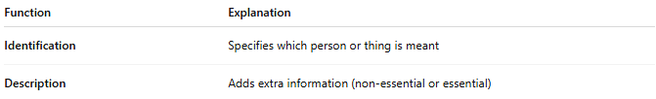
Function | Explanation
Identification | Specifies which person or thing is meant
Description | Adds extra information (non-essential or essential)

🔹 Types:
# Source: AI Source: Provided by: [Data Path: Persons Table -> ID Column: 1, Name_En Column: Motasem Essam] -> From: [Chatgpt (GPT‑5 Mini)] on [8/7/2025]
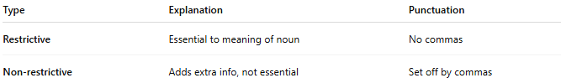
Type | Explanation | Punctuation
Restrictive | Essential to meaning of noun | No commas
Non-restrictive | Adds extra info, not essential | Set off by commas

🔹 Examples in Sentences:
# Source: AI Source: Provided by: [Data Path: Persons Table -> ID Column: 1, Name_En Column: Motasem Essam] -> From: [Chatgpt (GPT‑5 Mini)] on [8/7/2025]
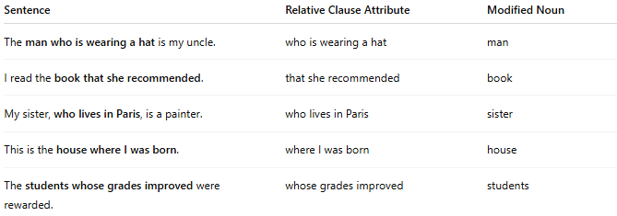
Sentence | Relative Clause Attribute | Modified Noun
The man who is wearing a hat is my uncle. | who is wearing a hat | man
I read the book that she recommended. | that she recommended | book
My sister, who lives in Paris, is a painter. | who lives in Paris | sister
This is the house where I was born. | where I was born | house
The students whose grades improved were rewarded. | whose grades improved | students

🔹 Quick Summary Table:
# Source: AI Source: Provided by: [Data Path: Persons Table -> ID Column: 1, Name_En Column: Motasem Essam] -> From: [Chatgpt (GPT‑5 Mini)] on [8/7/2025]
Type | Acts Like | Position | Introduced By | Modifies
Relative Clause Attribute | Adjective | After the noun | who, which, that, where... | Noun

